**Prioritization of Snake River Instream PIT Tag Detection Systems for Operations & Maintenance**

Version: July 31, 2023

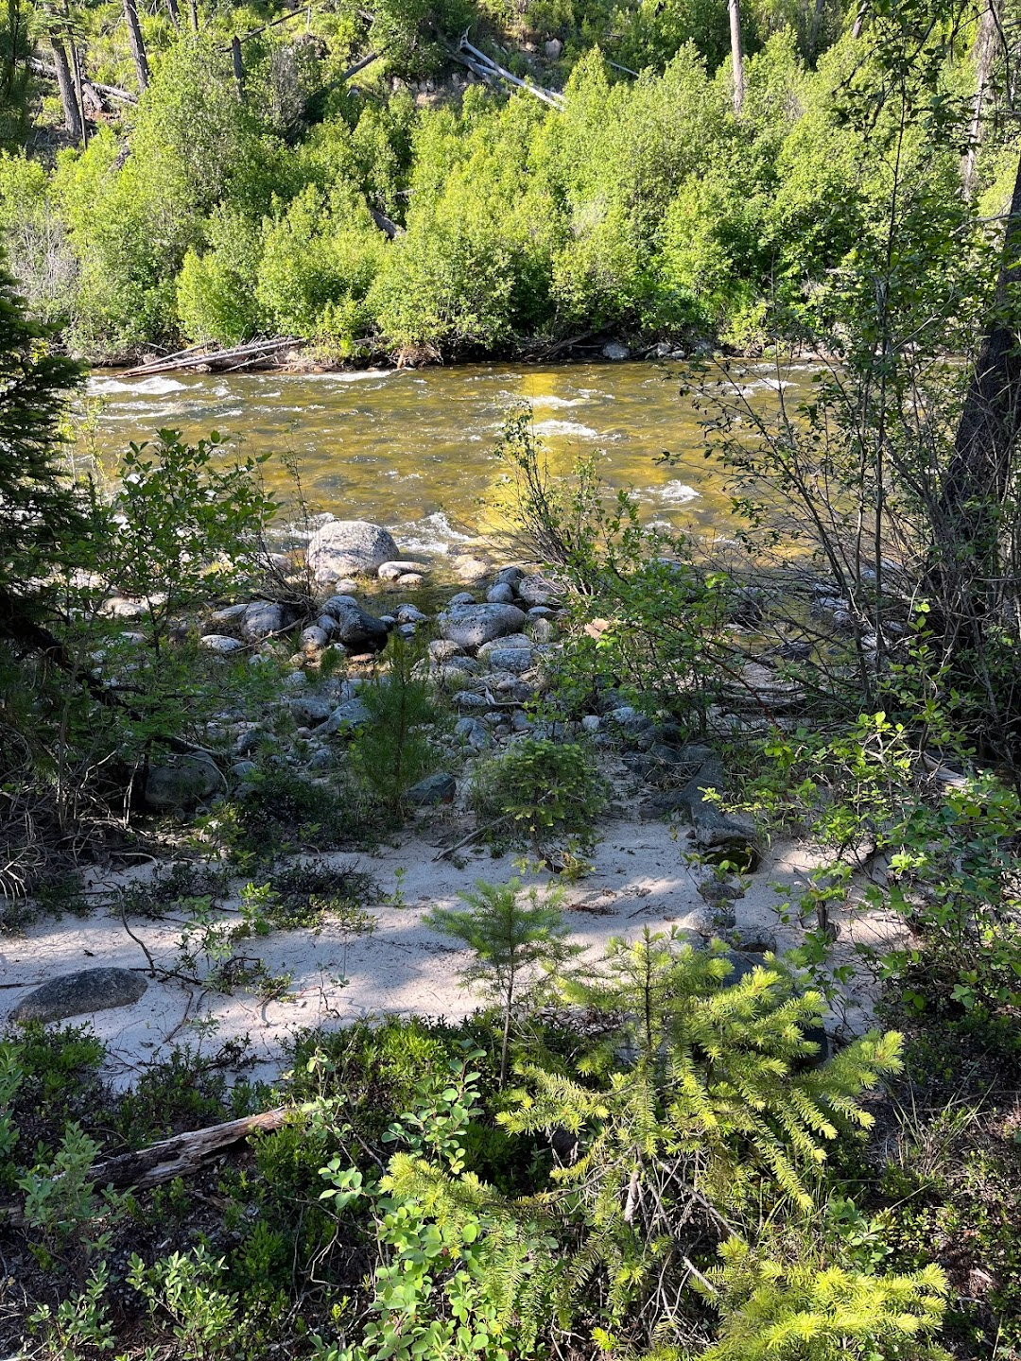

Add author group or list

Table of Contents

BACKGROUND 3

Objectives 3

GENERAL APPROACH 3

Abundance 3

Productivity 4

Diversity 4

PRIORITIZATION FRAMEWORK 4

RESULTS 9

Synopsis 9

Snake River Basin Steelhead DPS 10

Salmon River MPG 10

Clearwater River MPG 12

Imnaha River MPG 13

Grande Ronde River MPG 14

Hells Canyon MPG 15

Lower Snake MPG 15

Snake River Spring/Summer-run Chinook Salmon ESU 17

Upper Salmon River MPG 17

Middle Fork Salmon River MPG 19

South Fork Salmon River MPG 20

Grande Ronde / Imnaha River MPG 21

Lower Snake River MPG 22

DISCUSSION 23

LITERATURE CITED 24

**Suggested Citation:**

Add suggested citation

# BACKGROUND

Numerous Instream PIT tag Detection Systems (IPTDS) have been installed throughout the Snake, upper Columbia, and John Day River basins to support habitat action effectiveness and status and trends monitoring initiatives developed under the Integrated Status and Effectiveness Monitoring Project (ISEMP; BPA project number 2013-007-00). However, when ISEMP was largely defunded in 2017, comanagers identified a subset of IPTDS for which continued operation was of high priority, including in the Snake River basin. The Integrated IPTDS Operations and Maintenance (O&M) project (BPA project number 2018-002-00) was created to assume O&M responsibilities for a subset of IPTDS with continued status and trends monitoring and management utility.

## Objectives

Our objective is to provide recommendations on the continued funding of O&M for IPTDS throughout the Snake River basin, to be continued under Bonneville Power Administration (BPA) project number 2018-002-00 (Project), currently managed by Biomark, Inc. Here, the primary goal for prioritization and selection of IPTDS is to obtain status and trends information for spring/summer-run (sp/sum) Chinook salmon and summer-run steelhead populations in the basin, including high-precision monitoring in at least one population per major population group (MPG) following the recommendations of the Anadromous Salmonid Monitoring Strategy (ASMS; CBCAMW 2010). We recognize the importance that all individual IPTDS have and their ability to answer specific fish monitoring and research questions. However, our purpose is to prioritize the IPTDS sites required to obtain population abundance and life history high-level indicators[1] (HLI; PNAMP 2009) efficiently and reliably, and to recommend them for continued or improved O&M through BPA project 2018-002-00. Ultimately, our aim is to provide a transparent framework to identify the following recommendations and/or outcomes for IPTDS: 1) removal, 2) continued funding of O&M, 3) upgrades, and/or 4) new IPTDS to address gaps or to increase cost-savings.

# GENERAL APPROACH

Four general parameters form the key to evaluating a population’s viability status: abundance, productivity, spatial structure, and diversity (McElhany et al. 2000). The ASMS recommends the following general guidelines, among others, to assess these Viable Salmonid Population (VSP) criteria (CBCAMW 2010):

## Abundance

* Annual adult status and trend data should be collected at high intensity monitoring (precision) for *at least* one population per life history type (spring versus summer run) per MPG. This adult monitoring should be invested in populations with high intensity juvenile and smolt abundance monitoring.
* Annual adult status and trend data should be collected at lower intensity monitoring for every population within an MPG.
* Adult monitoring should report abundance and precision (confidence intervals, CI’s) on a yearly basis in a manner that will allow abundance (and uncertainty levels) to be aggregated at larger spatial scales (e.g., MPG or ESU/DPS).
* …

## Productivity

* Annual estimates of adult:adult productivity[2] and CI’s for each population.
* Annual estimates of juvenile and smolt migrants and CI’s for at least one population per MPG. Juvenile and smolt monitoring should be done in populations with high intensity adult monitoring to calculate smolts per female (or smolts per spawner).
* …

## Diversity

* Periodic sampling of populations for genetic diversity. Sample wild populations on a rotating five-year basis to maintain genetic baselines for genetic stock identification and to evaluate genetic population structure and diversity.
* Periodic monitoring of population phenotypic diversity (e.g., juvenile outmigration timing, adult run timing, spawn timing, age distribution, age at maturity, fecundity, sex ratio, size, and weight)

IPTDS throughout the Snake River basin can be used to monitor adult abundance and productivity directly, as well as spatial structure and diversity, indirectly (supported by genetic and age data collected at Lower Granite Dam or elsewhere). As such, we considered these ASMS guidelines within the following prioritization framework.

# PRIORITIZATION FRAMEWORK

1. First, we evaluated existing status and trends monitoring activities within each Snake River sp/sum Chinook salmon and steelhead population to determine areas with current insufficient monitoring (i.e., data gaps), or with low- or high-precision monitoring (see blue boxes in Figure 1). Descriptions of each are as follows:
   1. **Data Gap:** Population lacks low-precision or high-precision monitoring activities to calculate HLIs, i.e., the population lacks adult abundance estimates with precision in most years.
   2. **Low-precision Monitoring:** Population includes monitoring activities that lack information necessary to calculate HLI precision, the 5-year average coefficient of variation (CV) is > 15%, or the monitoring occurs at a spatial/temporal scale that excludes some fish returning to major spawning areas within the population. Examples of low-precision monitoring include spawning ground surveys, and picket weirs or IPTDS operated upstream of some major spawning areas[3].
   3. **High-precision Monitoring:** Population includes monitoring activities that provide the necessary information to calculate HLI precision, maintain a 5-year average CV of ≤ 15%, and occur at a spatial/temporal scale that includes all fish returning to major spawning areas within the population. Fish returning to minor spawning areas may be excluded. Examples of high-precision adult monitoring include picket weirs and IPTDS operated downstream of all spawning areas.
2. Next, depending on the current monitoring activities within each population (none, low-precision, or high-precision), additional questions were considered to determine an “outcome” (Figure 1). Questions considered whether other populations within the same MPG were monitored using high-precision monitoring, whether IPTDS was the sole monitoring method within the population, whether low-precision monitoring was an option, and/or whether redundancy in monitoring was desired or necessary. Each set of questions and answers leads to an “outcome” (Figure 1).
   1. **Data Gap:** The ASMS suggests that low-intensity monitoring should be conducted for every population within an MPG. Thus, populations identified as a “data gap” should be considered as a candidate for IPTDS monitoring and/or other low-precision monitoring methods.
   2. **Low-precision Monitoring:** For populations with current low-precision monitoring, we consider up to three questions:
      1. Does any other population within the same MPG receive high-precision monitoring?
      2. Is the population monitored using only IPTDS?
      3. Is an alternate low-precision monitoring method feasible?
   3. **High-precision Monitoring:** For populations with current high-precision monitoring, we consider up to five questions:
      1. Is the population currently monitored using IPTDS?
      2. Does any other population within the same MPG receive high-precision monitoring?
      3. Is IPTDS the only high-precision monitoring method used in the population?
      4. Is an alternate low-precision monitoring method feasible?
      5. Is redundancy of two high-precision methods necessary e.g., for method validation, fish-handling, etc.?

Depending on the “Yes/No” answers to each of these questions, there are four possible “outcomes” illustrated and described in Figure 1 and Table 1, respectively.

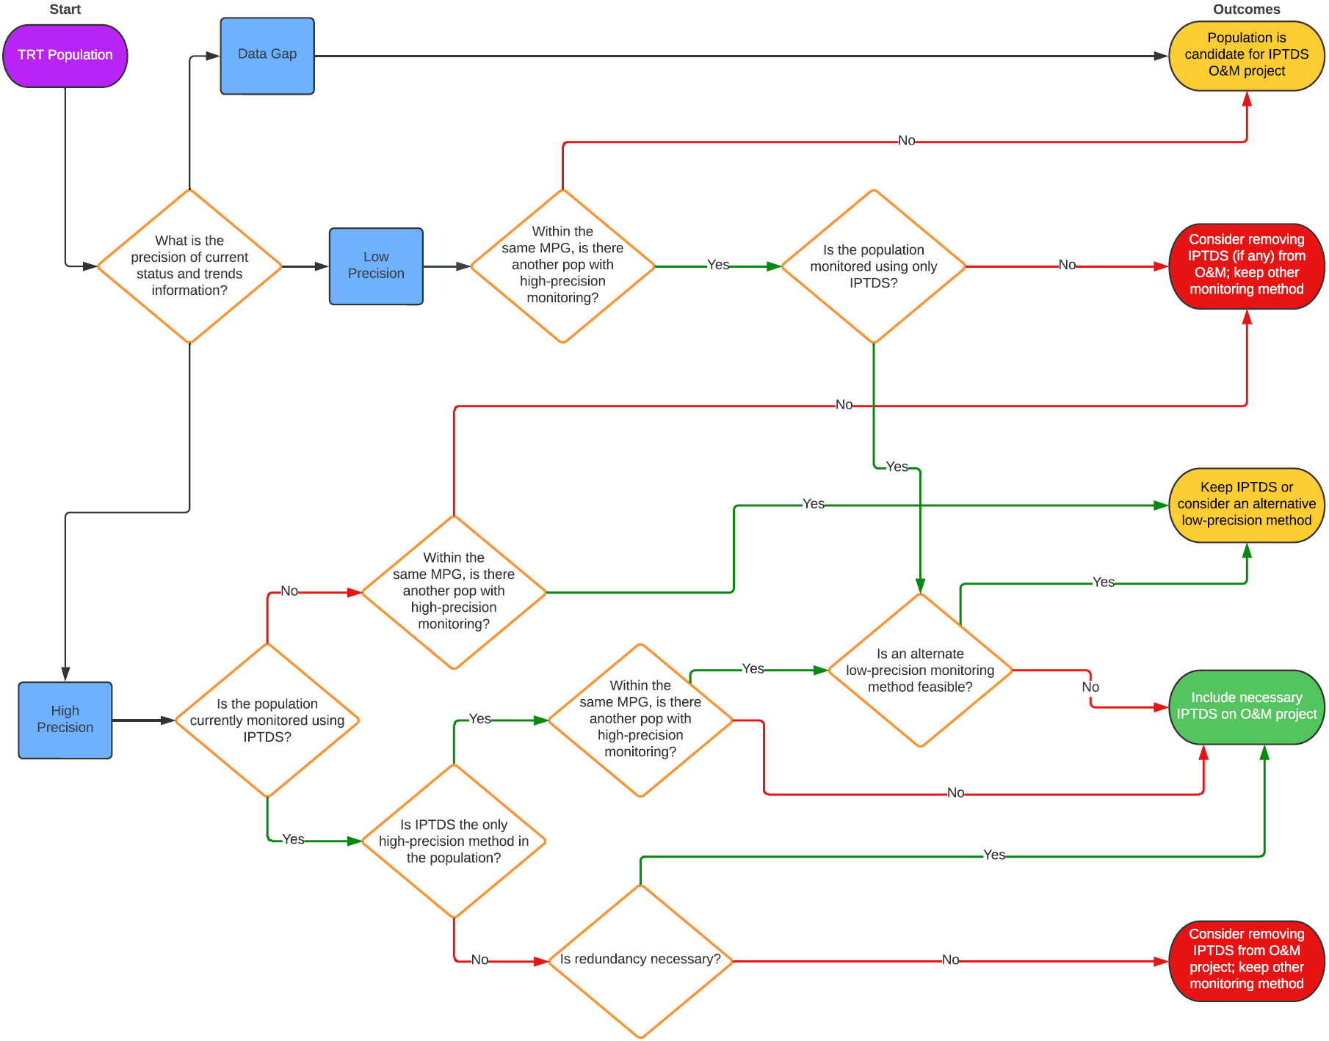

**Figure 1**. Flowchart used to determine monitoring needs for each Snake River sp/sum Chinook salmon and steelhead population, and whether IPTDS in each population should be considered for inclusion in BPA project 2018-002-00. Outcome colors are as follows: Red = candidate for removal from project 2018-002-00; yellow = further considerations needed; green = IPTDS should be operated under project 2018-002-00.

**Table 1**. Potential population-level outcomes resulting from the initial step of the prioritization framework. Red = candidate for removal from project 2018-002-00; yellow = further considerations needed; green = IPTDS should be operated under project 2018-002-00.

|  |  |
| --- | --- |
| **Outcome** | **Description** |
| **Consider removing IPTDS (if any) from O&M project; keep other monitoring method** | Outcome is for populations that either a) occur within an MPG in which another population is monitored using a high-precision method AND is monitored using another low-precision method, or b) is monitored using two redundant, high-precision methods including IPTDS and redundancy is not necessary. |
| **Population is candidate for IPTDS O&M project** | Outcome is for populations with currently no monitoring (i.e., data gaps) or for a population within an MPG that includes no populations with high-precision monitoring.[4] |
| **Keep IPTDS or consider an alternative low-precision method** | Outcome is for populations that currently experience high-precision IPTDS monitoring but occur within an MPG in which two or more populations are monitored using high-precision methods. |
| **Include necessary IPTDS on O&M project** | The population should continue to be monitored using IPTDS funded under the Integrated IPTDS O&M project. Three paths in Figure 1 lead to this outcome. In general, this outcome is for populations in which current IPTDS are necessary for either low-precision or high-precision monitoring. |

1. Finally, for each extant population, we further considered which IPTDS site(s) within the population are necessary for status and trends monitoring (low- or high-precision) and recommended for inclusion in project 2018-002-00 (Figure 2). Definitions and descriptions in Table 2 are provided to aid in interpretation of Figure 2.

**Table 2.** Definitions or descriptions that may be useful for interpretation of Figure 2.

| Term | Definition or Description |
| --- | --- |
| Nodes | A node is made up of a single, or group of, antenna(s) that form an independent PIT-tag detection location and can be ordered in reference to other nodes in the stream network. |
| Unbiased / Independent | IPTDS sites and/or nodes are independent if the probability of detecting a tag at one location is independent of detection at another site or node. For example, two nodes (e.g., arrays) within a short distance of each other (e.g., less than 10 meters) may not be independent if marked fish are not mixing with unmarked fish between the nodes. |
| Reliable | The site has operated continuously (or near continuously) through the adult migration period for each of the last five years for sp/sum Chinook salmon and steelhead. |

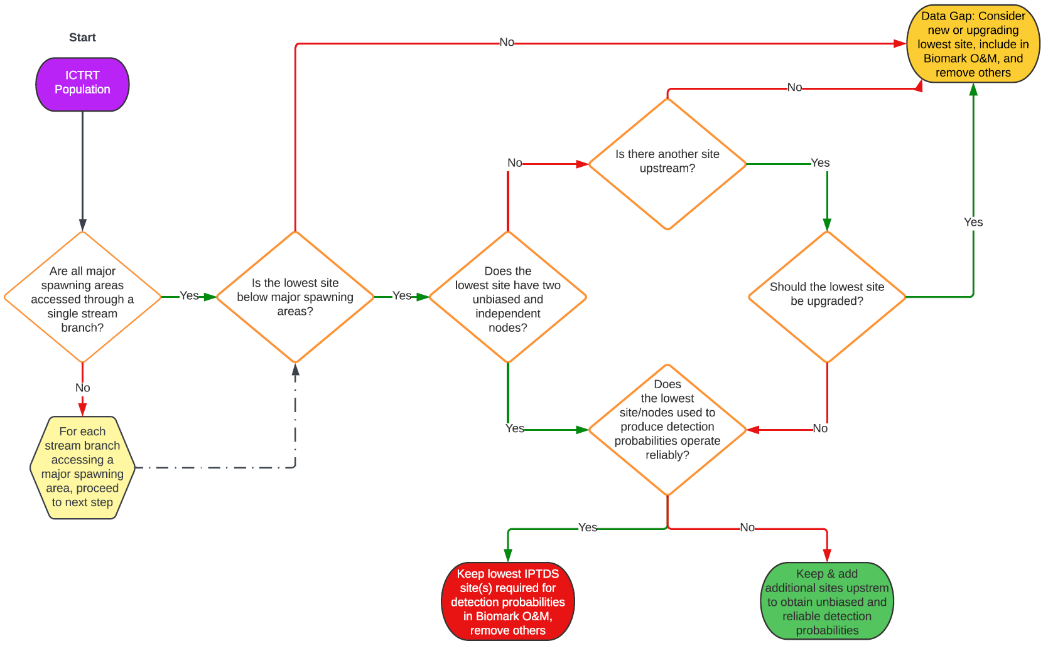

**Figure 2.** Within each population, determine which IPTDS(s) should be considered for inclusion in the IPTDS O&M project (BPA project 2018-002-00), and/or whether any IPTDS(s) within the population could be removed.

The goal of our site prioritization framework is to make recommendations as transparent and clear as possible. However, for some MPGs, populations, and IPTDS sites, “gray areas” exist, and professional judgement must occasionally be made which considers logistics, costs, site reliability, etc. Further, some recommendations for Snake River steelhead inevitably must consider sp/sum Chinook salmon, or vice-versa, and so both species were considered during the process. Considerations and recommendations for Snake River steelhead and sp/sum Chinook salmon, by MPG and population, follow.

# RESULTS

## Synopsis

Summary text…

## Snake River Basin Steelhead DPS

### Salmon River MPG

We recommend the continued funding of O&M for 9 sites that are currently managed by the IPTDS O&M project including VC2, USE, LLR, LRW, HYC, NFS, MAR, TAY, and ZEN. The SFMAI-s population is currently monitored by both the KRS and ESS sites (in addition to SFG); at least one of them should continue to be funded under the IPTDS O&M project. Six sites are candidates to be removed from the IPTDS O&M project as their data are not integral for population status and trends monitoring: USI, BHC, LLS, BLT, CAC, and SFG. Two existing sites could be considered for addition to the project: YFK and PCA. Finally, three proposed sites could be considered under the IPTDS O&M project including: (1) site for the SREFS-s population (e.g., lower East Fork Salmon River or Morgan Creek), (1) site in lower Chamberlain Creek, and (1) site in a major (e.g., lower Little Salmon or Rapid rivers) or minor (Rock, Whitebird, Skookumchuck, Slate) spawning area of the SRLSR-s population, if feasible.

**Table 3.** Populations within the Salmon River MPG, Snake River Basin Steelhead DPS including their status, current level of status and trends monitoring, and considerations and recommendations for each population for funding of IPTDS O&M for adult abundance monitoring.

| Pop ID | Pop Name | Status | Current Monitoring Type | Considerations | Recommendation |
| --- | --- | --- | --- | --- | --- |
| SRUMA-s | Salmon River upper mainstem | Extant | Low | Other populations within the MPG are currently monitored with high precision, and so only low precision monitoring is necessary. However, because no other major spawning areas are monitored using O&M funded IPTDS, VC2 should continue to be funded and upgrades considered. | Continue funding VC2; consider upgrades |
| SREFS-s | East Fork Salmon River | Extant | Data Gap | No monitoring currently occurs within the population i.e., the SREFS-s population is considered a data gap. An IPTDS should be considered to monitor a (large) portion of at least one major spawning area; possible locations include the lower East Fork Salmon River (East Fork major spawning area) or Morgan Creek (Challis major spawning area). | Add IPTDS in one of two (East Fork or Morgan) major spawning areas |
| SRPAH-s | Pahsimeroi River | Extant | High | The SRPAH-s population is currently monitored using the Pahsimeroi Hatchery weir and using USE and USI, which are O&M-funded. The USE provides more complete population coverage than the weir; however, an estimate of abundance at USE is reliant upon observations at USI and sites upstream (including Pahsimeroi weir) to estimate detection probabilities. Further, sites don’t exist upstream to appropriately “parse” abundance estimates to the SRUMA-s and SREFS-s populations from abundance at USE to estimate abundance for the SRPAH-s population. Since other populations within the MPG are monitored with high precision, USI could be removed, so long as sufficient IPTDS were maintained upstream to estimate a detection probability for USE. | Consider removing USI; if removed, maintain sufficient upstream sites to estimate detection probability at USE |
| SRLEM-s | Lemhi River | Extant | High | SRLEM-s is a strong candidate to maintain for high-precision monitoring despite other populations within the MPG also being high-precision, given that the Lemhi River is an Intensively Monitored Watershed with various RM&E activities within the population. However, for status and trends monitoring, LLR, LRW, and HYC are of highest priority for population and major spawning area monitoring. Other O&M funded sites (e.g., BHC, LLS, BTL, CAC) don’t need to be funded by the IPTDS O&M project. | Continue funding LLR, LRW, HYC; remove e.g., BHC, LLS, BTL, CAC from the project |
| SRNFS-s | North Fork Salmon River | Extant | High | Other populations within the MPG are monitored with high precision; however, adult escapement in SRNFS-s is only monitored using IPTDS and other low-precision methods are less or not feasible. | Continue funding NFS |
| SRPAN-s | Panther Creek | Extant | High | Other populations within the MPG are monitored with high precision; however, adult escapement in SRPAN-s is only monitored using IPTDS and other low-precision methods are less or not feasible. The PCA site could be considered for funding under the IPTDS O&M project to ensure long-term monitoring. | Consider funding PCA under IPTDS O&M project |
| SRCHA-s | Chamberlain Creek | Extant | Data Gap | The SRCHA-s population is currently considered a data gap. An IPTDS near the mouth of Chamberlain Creek, the lone major spawning area, or at least below much of the available spawning habitat, could be considered, if feasible. Alternatively, low-precision methods (e.g., genetic-based effective population size monitoring) in various tributaries, including Chamberlain Creek, throughout the population could also be considered. | Consider an IPTDS in Chamberlain Creek, if feasible |
| MFUMA-s | Middle Fork Salmon River upper mainstem | Extant | Low | One (Marsh Creek) of six major spawning areas within the population is monitored using O&M-funded IPTDS, which is the only adult escapement monitoring method in the population. The remaining five (Lower Bear, Upper Middle Fork Salmon, Rapid, Pistol, Marble) are unmonitored for adult escapement. Other populations within the MPG are currently monitored with high precision, and so only low precision monitoring is necessary. | Continue funding MAR |
| MFBIG-s | Big, Camas, and Loon Creek | Extant | Low | Three (Lower Big, Upper Big, Monumental) of five major spawning areas within the population are currently monitored (combined) by TAY, which is the only adult escapement monitoring method in the population. The remaining two (Upper Loon, Camas) are unmonitored for adult escapement. Other populations within the MPG are currently monitored with high precision, and so only low precision monitoring is necessary. | Continue funding TAY |
| SFMAI-s | South Fork Salmon River | Extant | High | Other populations within the MPG are monitored with high precision; however, adult escapement in SFMAI-s is only monitored using IPTDS and other low-precision methods are less or not feasible. Three major spawning areas (Upper South Fork Salmon, Johnson, Upper East Fork South Fork) exist in the population. High-precision monitoring of the population could occur using only KRS and ESS. Low-precision monitoring could occur using either KRS or ESS. | Continue funding KRS or ESS; SFG could be considered for removal from the IPTDS O&M project |
| SFSEC-s | Secesh River | Extant | High | Other populations within the MPG are monitored with high precision; however, adult escapement in SFSEC-s is only monitored using IPTDS and other low-precision methods are less or not feasible. | Continue funding ZEN |
| SRLSR-s | Little Salmon and Rapid River | Extant | Data Gap | The SRLSR-s population is currently a data gap. Low-precision monitoring of the population could be accomplished with an IPTDS near the mouth of a major (Little Salmon) or minor (e.g., Rock, Whitebird, Skookumchuck, Slate) spawning area. Other populations within the MPG are monitored with high precision, and so only low-precision monitoring is required. | Consider adding an IPTDS in a major or minor spawning area |

### Clearwater River MPG

We recommend the continued funding of O&M for 5 sites currently managed by the IPTDS O&M project: LRL, LRU, SC1, LC1, and LC2. Two existing sites should be considered for addition to the project: SW1 and SW2. In addition, at least two other sites within the CRSFC-s and CRLMA-s populations should be considered for funding; however, those don’t necessarily need to be SC2 or CRA, at least as currently configured.

To improve population status and trends monitoring for steelhead in the MPG, alternate site configurations could be considered within the CRSFC-s and CRLMA-s populations. For example, either the SC1 or SC2 site could be moved to near the bottom of the CRSFC-s population, or alternately, an IPTDS near the bottom of a major spawning area within the CRLMA-s population could be considered. Existing sites to consider funding under the IPTDS O&M project include JUL (Potlatch River), LAP (Lapwai River), or LAW (Lawyer Creek), if desired. Regardless, one site within the CRSFC-s population should be funded under the IPTDS O&M project to facilitate estimates of detection probabilities at downriver sites, but that site doesn’t necessarily need to be CRA. Low-precision monitoring for these two populations could likely be accomplished with better coverage and improved cost-savings by using 1) different site/array configurations, 2) funding alternate sites, or 3) a combination of both.

Two arrays should continue to be funded within the CRLOL-s population. However, LC2 is currently located at a site which is difficult for O&M. To reduce time and costs, it should be considered to either convert LC1 to a two-pass configuration or move LC2 upstream to a location easier for O&M, preferably downstream of major spawning areas.

**Table 4.** Populations within the Clearwater River MPG, Snake River Basin Steelhead DPS including their status, current level of status and trends monitoring, and considerations and recommendations for each population for funding of IPTDS O&M for adult abundance monitoring.

| Pop ID | Pop Name | Status | Current Monitoring Type | Considerations | Recommendation |
| --- | --- | --- | --- | --- | --- |
| CRSEL-s | Selway River | Extant | High | Other populations within the MPG are monitored with high precision; however, adult escapement in CRSEL-s is only monitored using IPTDS and other low-precision methods are less or not feasible. Detections at SW2 facilitate estimating the detection probability (and abundance) at SW1. | Consider funding SW1 and SW2 under IPTDS O&M project |
| CRLOC-s | Lochsa River | Extant | High | Other populations within the MPG are monitored with high precision; however, adult escapement in CRSEL-s is only monitored using IPTDS and other low-precision methods are less or not feasible. Detections at LRU facilitate estimating the detection probability (and abundance) at LRL. | Continue funding LRL and LRU |
| CRSFC-s | South Fork Clearwater River | Extant | Low | Other populations within the MPG are currently monitored with high precision, and so only low precision monitoring is necessary. An estimate for one tributary, Crooked River, within the population is currently possible using the two-pass CRA site. SC1 and SC2 allow for an abundance estimate for the entire South Fork Clearwater watershed; however, the CRSFC-s population boundary occurs well upstream of SC2 where Hwy 13 crosses the South Fork Clearwater River and abundance estimates at SC1/SC2 don’t account for e.g., pre-spawn mortality, harvest, etc. that occurs below the CRSFC-s population boundary. If improved monitoring was desired for the steelhead (and Chinook salmon population), a site could be considered near the crossing of Hwy 13 and below any major spawning areas (Newsome [includes Crooked River], American, Upper South Fork). If a site was moved to this new location, SC1 or SC2 could potentially be removed; the new site would either need to be a two-pass configuration or sites upstream (e.g., SC3, SC4, CRA) would need to be maintained to ensure that detection probabilities could be estimated. | No action needed to maintain low-precision monitoring. Alternate site configurations, including for SC1 and SC2, could be considered to improve cost-savings for the CRSFC-s and CRLMA-s populations. |
| CRLOL-s | Lolo Creek | Extant | High | Other populations within the MPG are monitored with high precision; however, adult escapement in CRLOL-s is only monitored using IPTDS and other low-precision methods are less or not feasible. Detections at LC2 facilitate estimating the detection probability (and abundance) at LC1; however, LC2 is a difficult site for O&M, so it could be considered to convert LC1 to a two-pass configuration or to move LC2 upstream in the watershed to an easier access location, but preferably downstream of major spawning areas. | Continue funding LC1 and LC2; consider changes to array configurations to reduce long-term costs |
| CRNFC-s | North Fork Clearwater River | Extirpated | - | - | - |
| CRLMA-s | Clearwater River lower mainstem | Extant | Low | Other populations within the MPG are monitored with high precision; however, adult escapement in CRLMA-s is only monitored using IPTDS and other low-precision estimates are less or not feasible. Two sites within the population are currently funded under the IPTDS O&M project (SC1 and SC2), but as noted above, those sites provide estimate of abundance for the South Fork Clearwater River, and not necessarily the CRSFC-s population (or the Lower SF Clearwater Tribs major spawning area). Alternatively, a site should be considered near the bottom of a major spawning area (Potlatch [JUL], Lapwai [LAP], Lawyer [LAW], Big Canyon, Lower SF Clearwater Tribs [SC1 or SC2]) within the CRLMA-s population funded under the IPTDS O&M project. Moving SC1 or SC2 to a new location at the bottom of CRSFC-s, or moving/funding SC3 (which occurs below all major spawning areas within CRSFC-s), would allow parsing estimates for the CRSFC-s population and Lower SF Clearwater tribs major spawning area. | No action needed to maintain low-precision monitoring. Alternate site configurations, including for SC1 and SC2, could be considered to improve cost-savings for the CRSFC-s and CRLMA-s populations or fund an existing or new site at the bottom of a major spawning area within CRLMA-s |

### Imnaha River MPG

We recommend the continued funding of O&M for 2 sites currently managed by the IPTDS O&M project: COC and IR1. One additional array or site upstream of IR1 should be funded under the project to allow estimation of the detection probability at IR1. This could include converting IR1 to a two-pass configuration, continued funding of the BSC or IR3 sites, or moving funding from BSC/IR3 to another existing site within the population important for status and trends monitoring. Funding for O&M of other sites could be removed from the IPTDS O&M project, assuming that three sites would provide sufficient detections, and adequate detection probabilities, to estimate abundance of the IRMAI-s population for status and trends monitoring.

**Table 5.** Populations within the Imnaha River MPG, Snake River Basin Steelhead DPS including their status, current level of status and trends monitoring, and considerations and recommendations for each population for funding of IPTDS O&M for adult abundance monitoring.

| Pop ID | Pop Name | Status | Current Monitoring Type | Considerations | Recommendation |
| --- | --- | --- | --- | --- | --- |
| IRMAI-s | Imnaha River | Extant | High | IRMAI-s is the only population in the MPG and so should be monitored with high precision. High-resolution monitoring could be accomplished using IR1 as the site is below all major spawning areas. In addition, one additional array upstream of IR1 should be funded under the IPTDS O&M project to allow estimation of a detection probability at IR1. Currently, five sites within the population are funded under the project; however, only two are necessary, given sufficient detections to estimate abundance at IR1 for status and trends monitoring. COC would provide complete coverage for the population, but is not necessary, as Cow Creek is a minor spawning area. | Continue funding IR1 plus one additional site or array upstream of IR1 |

### Grande Ronde River MPG

We recommend the continued funding of O&M for 3 sites currently managed by the IPTDS O&M project: UGR, WR1, and JOC. In addition, WEN should be considered for funding under the project.

Alternative site or array configurations for the GRWAL-s population could be considered to reduce time and costs and improve population status and trends monitoring, if desired.

**Table 6.** Populations within the Grande Ronde River MPG, Snake River Basin Steelhead DPS including their status, current level of status and trends monitoring, and considerations and recommendations for each population for funding of IPTDS O&M for adult abundance monitoring.

|  |  |  |  |  |  |
| --- | --- | --- | --- | --- | --- |
| Pop ID | Pop Name | Status | Current Monitoring Type | Considerations | Recommendation |
| GRUMA-s | Grande Ronde River upper mainstem | Extant | Low | Other populations within the MPG are monitored with high precision, and so only low-precision monitoring is required. UGR, currently funded by the IPTDS O&M project, provides low-precision monitoring as it doesn’t capture abundance for the Lookingglass major spawning area. | Continue funding UGR |
| GRWAL-s | Wallowa River | Extant | High | Other populations within the MPG are monitored with high precision, and so only low-precision monitoring is required. WR1, funded under the IPTDS O&M, is a single-pass array used to estimate abundance for the GRWAL-s population. Two upstream sites not funded under the project (MR1 and WR2) provide detections to estimate a detection probability at WR1. No actions are needed, provided that MR1 and WR2 are maintained; otherwise, consider funding an existing upstream site under the IPTDS O&M project. In addition, alternate configurations of sites and arrays in the population could be considered to reduce costs for status and trends monitoring, if desired. | Continue funding WR1; alternate site/array configurations could be considered to reduce costs and ensure long-term monitoring |
| GRJOS-s | Joseph Creek | Extant | High | Other populations within the MPG are monitored with high precision; however, adult escapement in GRJOS-s is only monitored using IPTDS and other low-precision methods are less or not feasible. Moreover, JOC is a two-pass array site and is in an ideal location for population status and trends monitoring and so should be maintained to ensure high-precision monitoring of a population within the Grande Ronde River MPG. | Continue funding JOC |
| GRLMT-s | Grande Ronde River lower mainstem tributaries | Extant | Low | Other populations within the MPG are monitored with high precision; however, adult escapement in GRLMT-s is only monitored using IPTDS and other low-precision methods are less or not feasible. WEN, the only site within the population monitoring adult status and trends, is currently not funded under the IPTDS O&M project, and so should be considered for funding under the project. | Consider funding WEN |

### Hells Canyon MPG

The lone population in the MPG (SNHCT-s) is extirpated, and so no considerations for the MPG were made.

**Table 7.** Populations within the Hells Canyon MPG, Snake River Basin Steelhead DPS including their status, current level of status and trends monitoring, and considerations and recommendations for each population for funding of IPTDS O&M for adult abundance monitoring.

| Pop ID | Pop Name | Status | Current Monitoring Type | Considerations | Recommendation |
| --- | --- | --- | --- | --- | --- |
| SNHCT-s | Hells Canyon | Extirpated | - | - | - |

### Lower Snake MPG

Currently, neither of the two steelhead populations within the Lower Snake MPG are monitored with high precision, including IPTDS. Current IPTDS-based monitoring in the SNTUC-s populations is, at least partially, reliant on “fallbacks” tagged at Lower Granite Dam, which are not representative of the run-at-large into the population. And thus, current IPTDS-based abundance estimates in the SNTUC-s population are considered low-precision. Current abundance estimates for the SNASO-s population do not account for abundance in the Alpowa Creek major spawning area, and so are also considered low-precision. Because SNASO-s occurs upstream of Lower Granite Dam, high precision adult escapement monitoring is likely more feasible in that population. We recommend funding an IPTDS in lower Asotin Creek (e.g., ACM) and consider adding a site in lower Alpowa Creek to ensure long-term, high precision monitoring. No action is needed in SNTUC-s if existing monitoring in the population continues.

**Table 8.** Populations within the Lower Snake MPG, Snake River Basin Steelhead DPS including their status, current level of status and trends monitoring, and considerations and recommendations for each population for funding of IPTDS O&M for adult abundance monitoring.

| Pop ID | Pop Name | Status | Current Monitoring Type | Considerations | Recommendation |
| --- | --- | --- | --- | --- | --- |
| SNASO-s | Asotin Creek | Extant | Low | Neither population within the MPG is monitored with high precision; IPTDS-based monitoring in the SNTUC-s population is (at least partially) reliant on “fallbacks” PIT-tagged at Lower Granite Dam and no IPTDS-based monitoring occurs in Alpowa Creek, a major spawning area in SNASO-s. High-precision monitoring within the SNASO-s is likely more feasible because it occurs upstream of Lower Granite Dam. | Consider funding ACM; consider adding site in Alpowa Creek |
| SNTUC-s | Tucannon River | Extant | Low | Neither population within the MPG is monitored with high precision; IPTDS-based monitoring in the SNTUC-s population is (at least partially) reliant on “fallbacks” PIT-tagged at Lower Granite Dam and no IPTDS-based monitoring occurs in Alpowa Creek, a major spawning area in SNASO-s. High-precision monitoring within the SNASO-s is likely more feasible because it occurs upstream of Lower Granite Dam. No action is needed, as long as alternative low-precision monitoring continues. | No action needed, if alternative low-precision monitoring continues |

## Snake River Spring/Summer-run Chinook Salmon ESU

### Upper Salmon River MPG

We recommend the continued funding of O&M for six sites that are currently managed by the IPTDS O&M project including VC2, USE, LLR, LRW, HYC, and NFS. Five sites could be removed from the IPTDS O&M project as their data are not integral for population status and trends monitoring: USI, BHC, LLS, BLT, and CAC. One proposed site is recommended under the IPTDS O&M project to provide monitoring for the SREFS-s steelhead population, which would also provide improved monitoring for the SREFS Chinook salmon population and Upper Salmon River MPG. A site in the lower East Fork Salmon River would better allow for parsing of IPTDS-based abundance estimates throughout the Upper Salmon River subbasin.

**Table 9.** Populations within the Upper Salmon MPG, Snake River Spring/Summer-run Chinook Salmon ESU including their status, current level of status and trends monitoring, and considerations and recommendations for each population for funding of IPTDS O&M for adult abundance monitoring.

| Pop ID | Pop Name | Run | Status | Current Monitoring Type | Considerations | Recommendation |
| --- | --- | --- | --- | --- | --- | --- |
| SRUMA | Salmon River upper mainstem above Redfish Lake | Spring | Extant | High | Other populations within the MPG are monitored with high precision, and so only low-precision monitoring is required. The SRUMA population is monitored using the Sawtooth Hatchery weir and redd counts[5] (boat, ground, UAS); no additional monitoring necessary. | No action needed |
| SRVAL | Valley Creek | Spring / Summer | Extant | High | Other populations within the MPG are monitored with high precision, and so only low-precision monitoring is required. The SRVAL population is monitored using redd counts (ground). VC2 is the only site within the SRVAL-s steelhead population and is recommended for continued funding. | Continue funding VC2 |
| SRLMA | Salmon River lower mainstem below Redfish Lake | Spring / Summer | Extant | Low | Other populations within the MPG are monitored with high precision, and so only low-precision monitoring is required. The SRLMA population is monitored using redd counts (UAS). In addition, USE and USI, which are O&M funded, currently provide monitoring for the population. Estimates of abundance at USE are partially reliant on observations at USE and upstream to estimate a detection probability at USE. Further, some sites don’t exist upstream to appropriately “parse” abundance estimates to e.g., SREFS from SRLMA. Because other populations are currently monitoring with high precision, USI could be considered for removal from the project, especially if other upstream sites provide adequate detections to estimate a detection probability at USE. | Consider removing USI from IPTDS O&M project |
| SRYFS | Yankee Fork Salmon River | Spring | Extant | High | Other populations within the MPG are monitored with high precision, and so only low-precision monitoring is required. The SRYFS population is currently monitored using a weir, the YFS site, and redd counts (ground, UAS); no additional methods needed. | No action needed |
| SREFS | East Fork Salmon River | Spring / Summer | Extant | Low | Other populations within the MPG are monitored with high precision, and so only low-precision monitoring is required. The SREFS population is currently monitored using redd counts (ground, UAS). An IPTDS is recommended for the lower East Fork Salmon River to address monitoring for the SREFS-s steelhead populations, which would improve overall monitoring for the SREFS population and Upper Salmon River Chinook salmon MPG. | No action needed; however, a new site proposed for steelhead would improve monitoring for the Chinook salmon population and MPG |
| SRPAH | Pahsimeroi River | Summer | Extant | High | The SRPAH population is the only summer-run population in the MPG and so high-precision monitoring is required. The Pahsimeroi Hatchery weir currently provides high-precision monitoring for the population, and the population is also monitoring with redd counts (ground, UAS). No IPTDS necessary, so long as the Pahsimeroi Hatchery weir continues to operate. | No action needed |
| SRLEM | Lemhi River | Spring | Extant | High | Other populations within the MPG are monitored with high precision, and so only low-precision monitoring is required. The SRLEM population is monitored using redd counts (ground, UAS), which provides low-precision monitoring. However, the SRLEM population is a strong candidate for high-precision monitoring despite other populations in the MPG also being monitored with high precision, given that it is an Intensively Monitored Watershed with various RM&E activities. For steelhead, it is recommended that LLR, LRW, and HYC are of highest priority for status and trends monitoring and would provide additional monitoring for SRLEM. Other O&M funded sites (e.g., BHC, LLS, BTL, CAC) don’t need to be funded by the IPTDS O&M project. | Continue funding LLR, LRW, HYC; consider removing BHC, LLS, BTL, CAC from the IPTDS O&M project |
| SRNFS | North Fork Salmon River | Spring | Extant | High | Other populations within the MPG are monitored with high precision, and so only low-precision monitoring is required. The SRNFS is currently monitored using redd counts (ground). The NFS site is recommended for continued monitoring of the SRNFS-s steelhead population and provides improved monitoring for the SRNFS Chinook salmon population. | No action needed; continue funding NFS |
| SRPAN | Panther Creek | Unknown | Extirpated | - | - | - |

### Middle Fork Salmon River MPG

No action is necessary for the Middle Fork Salmon River MPG, Snake River spring/summer-run Chinook salmon. We recommend continued funding of the MAR and TAY sites.

**Table 10.** Populations within the Middle Fork Salmon River MPG, Snake River Spring/Summer-run Chinook Salmon ESU including their status, current level of status and trends monitoring, and considerations and recommendations for each population for funding of IPTDS O&M for adult abundance monitoring.

| Pop ID | Pop Name | Run | Status | Current Monitoring Type | Considerations | Recommendation |
| --- | --- | --- | --- | --- | --- | --- |
| MFBEA | Bear Valley Creek | Spring | Extant | High | Other populations within the MPG are monitored with high precision, and so only low-precision monitoring is required. MFBEA is currently monitored using the Bear Valley weir and redd counts (ground). No action needed. If the Bear Valley weir were to be removed, an IPTDS funded under the O&M project could be considered. | No action needed |
| MFMAR | Marsh Creek | Spring | Extant | High | Other populations within the MPG are monitored with high precision, and so only low-precision monitoring is required. MFMAR is currently monitored using MAR and redd counts (ground). The MAR site is recommended for continued monitoring of the MFUMA-s steelhead population and provides improved monitoring for the MFMAR Chinook salmon population. | No action needed; continue funding MAR |
| MFSUL | Sulphur Creek | Spring | Extant | Low | Other populations within the MPG are monitored with high precision, and so only low-precision monitoring is required. MFSUL is current monitored using redd counts (ground); no additional monitoring needed. | No action needed |
| MFUMA | Middle Fork Salmon River above Indian Creek | Spring | Extant | Low | Other populations within the MPG are monitored with high precision, and so only low-precision monitoring is required. MFUMA is currently monitored using index redd count surveys (helicopter); no additional methods needed. | No action needed |
| MFLMA | Middle Fork Salmon River below Indian Creek | Spring / Summer | Extant | Low | Other populations within the MPG are monitored with high precision, and so only low-precision monitoring is required. MFLMA is currently monitored using index redd count surveys (raft); no additional methods needed. | No action needed |
| MFLOO | Loon Creek | Spring / Summer | Extant | Low | Other populations within the MPG are monitored with high precision, and so only low-precision monitoring is required. MFLOO is currently monitored using index redd count surveys (helicopter); no additional methods needed. | No action needed |
| MFCAM | Camas Creek | Spring / Summer | Extant | Low | Other populations within the MPG are monitored with high precision, and so only low-precision monitoring is required. MFCAM is currently monitored using index redd count surveys (helicopter); no additional methods needed. | No action needed |
| MFBIG | Big Creek | Spring / Summer | Extant | High | Other populations within the MPG are monitored with high precision, and so only low-precision monitoring is required. However, the MFBIG population provides a unique opportunity for high-resolution monitoring of a (largely) wilderness population paired with a rotary screw trap and is only one of two populations in the MPG with IPTDS-based high-resolution monitoring. The TAY IPTDS provides monitoring for three major spawning areas (Lower Big, Monumental, Upper Big). | Continue funding TAY |
| SRCHA | Chamberlain Creek | Spring | Extant | Low | Other populations within the MPG are monitored with high precision, and so only low-precision monitoring is required. SRCHA is currently monitored using index redd count surveys; no additional methods needed. | No action needed |

### South Fork Salmon River MPG

We recommend the continued funding of O&M for 2 sites that are currently managed by the IPTDS O&M project: KRS and ZEN. Two sites could be considered for removal from the IPTDS O&M project (SFG and ESS) as their data are not integral for population status and trends monitoring (CBCAMW 2010).

**Table 11.** Populations within the South Fork Salmon River MPG, Snake River Spring/Summer-run Chinook Salmon ESU including their status, current level of status and trends monitoring, and considerations and recommendations for each population for funding of IPTDS O&M for adult abundance monitoring.

| Pop ID | Pop Name | Run | Status | Current Monitoring Type | Considerations | Recommendation |
| --- | --- | --- | --- | --- | --- | --- |
| SFSMA | South Fork Salmon River mainstem | Summer | Extant | High | Other populations within the MPG are monitored with high precision, and so only low-precision monitoring is required. SFSMA is currently monitored using SFG and KRS, (using ZEN and ESS to “parse” out those populations), the South Fork Salmon River weir, and redd count surveys (ground). The population could be monitored with low precision without SFG and KRS, but it is recommended that either ESS or KRS continue to be funded to ensure monitoring of the SFMAI-s steelhead population. SFG and/or KRS could be considered for removal from the IPTDS O&M project. | Consider removing SFG and/or KRS from IPTDS O&M project |
| SFEFS | East Fork South Fork Salmon River | Summer | Extant | High | Other populations within the MPG are monitored with high precision, and so only low-precision monitoring is required. The SFEFS population is currently monitored using ESS, the Johnson Creek weir, and redd count surveys (ground). The population could be monitored with low precision without ESS, but if so, either the SFSMA or SFSEC populations need to be monitored with high precision i.e., using KRS or ZEN. | ESS could be considered for removal from IPTDS O&M project; but if removed, both KRS and ZEN funding would need to be maintained |
| SFSEC | Secesh River | Summer | Extant | High | Other populations within the MPG are monitored with high precision, and so only low-precision monitoring is required. The SFSEC population is currently monitored using ZEN and redd count surveys (ground). The SFSEC population could be monitored with low precision without ZEN; however, ZEN is needed for monitoring the SFSEC-s steelhead population. | Continue funding ZEN |
| SRLSR | Little Salmon River | Spring / Summer | Extant | Low | Other populations within the MPG are monitored with high precision, and so only low-precision monitoring is required. The SRLSR population is currently monitored using redd count surveys (ground); no additional methods needed. | No action needed |

### Grande Ronde / Imnaha River MPG

Recommendations for the MPG are largely driven by recommendations for the Imnaha River and Grande Ronde River MPGs for the Snake River Basin steelhead DPS. We recommend the continued funding of O&M for 3 sites that are currently managed by the IPTDS O&M project: IR1, UGR, and WR1. In addition, at least one addition site upstream of IR1 should be funded to ensure adequate detection to estimate a detection probability at IR1. Finally, MR1 or WEN are recommended to be considered for funding under the project to maintain appropriate monitoring for steelhead, which would additionally ensure high-precision monitoring for the GRMIN and GRWEN Chinook salmon populations.

**Table 12.** Populations within the Grande Ronde / Imnaha River MPG, Snake River Spring/Summer-run Chinook Salmon ESU including their status, current level of status and trends monitoring, and considerations and recommendations for each population for funding of IPTDS O&M for adult abundance monitoring.

| Pop ID | Pop Name | Run | Status | Current Monitoring Type | Considerations | Recommendation |
| --- | --- | --- | --- | --- | --- | --- |
| IRBSH | Big Sheep Creek | Spring | Functionally Extirpated | - | - | - |
| IRMAI | Imnaha River mainstem | Spring / Summer | Extant | High | Other populations within the MPG are monitored with high precision, and so only low-precision monitoring is required. High-precision monitoring is required for the IRMAI-s steelhead population and so those considerations/recommendations should be followed. | Continue funding IR1 plus one additional site or array upstream of IR1 |
| GRUMA | Grande Ronde River upper mainstem | Spring | Extant | High | Other populations within the MPG are monitored with high precision, and so only low-precision monitoring is required. The GRUMA population is currently monitored using a weir and redd counts; additionally, UGR provides an abundance estimate for the combined GRUMA and GRCAT populations. | No action needed; continue funding UGR |
| GRCAT | Catherine Creek | Spring | Extant | High | Other populations within the MPG are monitored with high precision, and so only low-precision monitoring is required. The GRUMA population is currently monitored using a weir and redd counts; additionally, UGR provides an abundance estimate for the combined GRUMA and GRCAT populations. | No action needed; continue funding UGR |
| GRLOO | Lookingglass Creek | Unknown | Functionally Extirpated | - | - | - |
| GRMIN | Minam River | Spring | Extant | High | Other populations within the MPG are monitored with high precision, and so only low-precision monitoring is required. MR1, currently not funded under the IPTDS O&M project, is recommended for funding to improve monitoring of the GRWAL-s steelhead population. Funding MR1 would additionally ensure high-resolution monitoring for at least one population in the Chinook salmon MPG. | Consider funding MR1 under the IPTDS O&M project |
| GRLOS | Lostine River | Spring | Extant | High | Other populations within the MPG are monitored with high precision, and so only low-precision monitoring is required. The GRLOS population is currently monitored using a weir, redd counts surveys, and WR1 and WR2 (using MR1 to “parse” abundance for the GRMIN population). WR1 is recommended for monitoring of the GRWAL-s steelhead population, and so those considerations/recommendations should be followed. | Continue funding WR1 |
| GRWEN | Wenaha River | Spring | Extant | High | Other populations within the MPG are monitored with high precision, and so only low-precision monitoring is required. WEN is recommended for monitoring of the GRLMT-s steelhead population, and so those considerations/recommendations should be followed. | Consider funding WEN under the IPTDS O&M project |

### Lower Snake River MPG

The SNASO population is considered functionally extirpated, and thus, high-precision monitoring of the remaining SNTUC population is desired. Currently, no O&M project IPTDS exist in the MPG. Funding of an IPTDS site(s) could be considered for funding under the IPTDS O&M project if it could support high-resolution monitoring.

**Table 13.** Populations within the Lower Snake River MPG, Snake River Spring/Summer-run Chinook Salmon ESU including their status, current level of status and trends monitoring, and considerations and recommendations for each population for funding of IPTDS O&M for adult abundance monitoring.

| Pop ID | Pop Name | Run | Status | Current Monitoring Type | Considerations | Recommendation |
| --- | --- | --- | --- | --- | --- | --- |
| SNASO | Asotin Creek | Spring | Functionally Extirpated | - | - | - |
| SNTUC | Tucannon River | Spring | Extant | High | The only other population in the MPG, SNASO, is considered functionally extirpated and so high-precision monitoring is desired. IPTDS-based abundance monitoring of the SNTUC-s population is (at least partially) reliant on “fallbacks” PIT-tagged at Lower Granite Dam, and so only provides low-precision monitoring. Alternate high-precision methods should be considered if not already in place; however, it IPTDS could be used to support high-precision monitoring, their funding could be considered under the IPTDS O&M project. | Consider funding IPTDS in the SNTUC population if they could support high-resolution monitoring |

# DISCUSSION

* Attempt was to be transparent and develop a framework to make decisions as black-and-white as possible, but best judgement is inevitable for gray areas
* What to do for most remote populations or flashy systems, where IPTDS might not be appropriate? Is genetic-based effective population size monitoring a viable low-precision solution?
* In some cases, an estimate of abundance at a site funded by the project is reliant on detections at sites not funded by the project? Is it worth funding those, at least in some cases?

Text…

# LITERATURE CITED

Columbia Basin Coordinated Anadromous Monitoring Workshop (CBCAMW). 2010. Anadromous Salmonid Monitoring Strategy Viable Salmonid Population Criteria and Subset of Tributary Habitat and Hatchery Effectiveness, Version 30062010. 59 pp.

Crawford, B.A. and S. Rumsey. 2009. Guidance for Monitoring Recovery of Pacific Northwest Salmon and Steelhead Listed Under the Federal Endangered Species Act (Idaho, Oregon, and Washington), DRAFT. NOAA’s National Marine Fisheries Service – Northwest Region. 129 pp.

McElhany, P., M.H. Ruckelshaus, M.J. Ford, T.C. Wainwright, and E.P. Bjorkstedt. 2000. Viable salmonid populations and the recovery of evolutionary significant units. U.S. Dept. Commer., NOAA Tech Memo. NMFS-NWFSC-42. 156 pp.

Pacific Northwest Aquatic Monitoring Partnership (PNAMP). 2009. High Level Indicators for Watershed Health and Salmon. May 12, 2009. 10 pp.

Poole, J.R., E.A. Felts, B. Barnett, M. Davison, M. Heller, R. Hand, and E. Brown. 2022. Idaho Adult Chinook Salmon Monitoring. Annual Report 2021. Idaho Department of Fish and Game Report 22-05.

1. HLIs are intended to communicate complex information in easily understood terms. HLIs for salmon include abundance of wild and hatchery spawners, among others (PNAMP 2009). After NOAA’s monitoring guidance was completed (e.g., Crawford and Rumsey 2009) it was intended that additional HLIs, e.g., to convey life history information, would be identified for salmon and steelhead.
2. Examples of adult:adult productivity include adult recruits per adult spawner or lifetime reproductive success.
3. Genetic-based effective population size monitoring (e.g., Hargrove 2022, Ackerman 2017) is another potential example of low- or high-resolution monitoring; however, estimates of effective population size or effective number of breeders must be converted to abundance which is still a relatively new and unvalidated technique.
4. For sp/sum Chinook salmon, annual adult status and trend data should be collected at high-intensity monitoring for at least one population per run-type (spring versus summer-run) within each MPG (CBCAMW 2010)
5. Redd count index transect methods throughout for surveys completed in Idaho in SY2021 were identified in Poole et al. (2022).